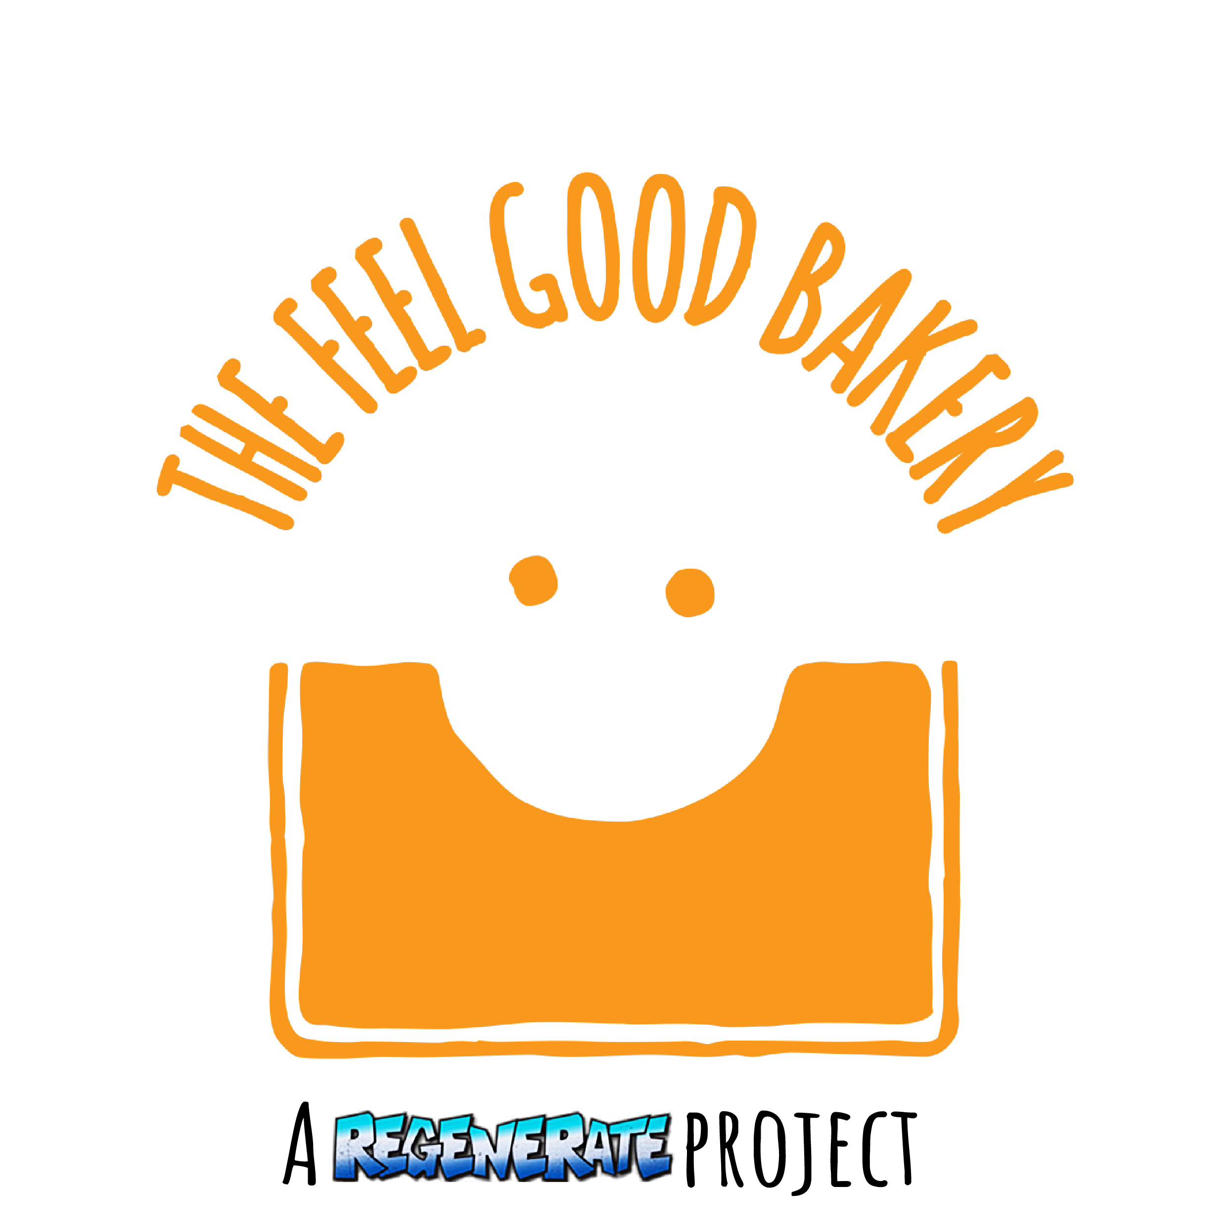

Job Description and Person Specification

Job Title: TFGB Coffee Shop Supervisor

Contract type: Permanent

Responsible to: TFGB General Manager

Location: Based at the Ashburton youth club, Putney and mobile outlet in Wandsworth.

Salary: £20K- £23K pro rata depending on experience

Hours: Job Share – 28 hours per week over 5 days including weekends and occasional evenings.
Annual Leave: 20 days plus public holidays pro rata
Overview:
The Feel Good Bakery is looking to recruit two highly motivated and hardworking individuals in a job share as the Coffee Shop Supervisor for this exciting social enterprise. The enterprise is owned by SW London charity, Regenerate. The enterprise is a mobile coffee shop business, training, mentoring and employing unemployed young people, young offenders, and young people at risk of offending. For every sandwich or coffee sold we will also provide a meal for a child in one of our partner feeding programs in Africa or Eastern Europe.
The Feel Good Bakery is entering an exciting period of growth in size and impact as a charity, and this new role is to manage the mobile coffee shop outlet and its employees. It is an exciting opportunity for an ambitious person passionate about using their skills in catering/business and in working with young people and young adults. This new project is building on the work of Regenerate to create employment opportunities for young people who are turning their lives around.
Reporting to The Feel Good Bakery General Manager, the role will be responsible for maintaining the mobile coffee shop, sales and supervising and coaching the young people in their employment.
Looking for someone to start as soon as possible.
Main Tasks and Responsibilities
Operations
- Maintain and develop systems and procedures to ensure the TFGB coffee shop runs efficiently and is maintained to the highest standards.
- Ensure the outlet’s cleanliness and hygiene standards are met each day, recorded and are kept in accordance with food safety standards.
- Handling customer enquiries and complaints.
- Manage food/drink preparation and sales.
- Carry out weekly stock checks and keep accurate records.
- Oversee product quality and carry out quality control checks to make sure standards are maintained.
- Work with the TFGB General Manager to decide on new products to sell and help develop these.
People management
- Manage a team of young adults (The Feel Good Bakery team members ) in the kitchen to ensure good ream moral and effective production.
- Manage team rotas and time sheets.
- Organise training and supervision for The Feel Good Bakery team members.
- Liaise with The Feel Good Bakery General Manager and contribute to the TFGB team development program to ensure relevant support and professional development.
- Work with the TFGB management team to ensure efficient running of bakery production and delivery.
Internal Relations:
- Contribute to team meetings.
- Manage coffee shop team.
- Meet regularly with the TFGB General Manager and management team to ascertain and work towards personal development plans for the TFGB team.
- Attend strategic days away with the TFGB team and contribute to the development of the Community interest company as a whole.

Relationships
Internal
- TFGB management team.
- TFGB team members.

Discretion to Act
Responsible to the General Manager for the delivery of work as agreed within the working group and with the Development Director, and in accordance with annual plan of work and Regenerate’s organisation strategy. All work must be contributing towards achieving the specified outcomes and objectives.
Perform other duties as instructed by the General Manager.

Environment
- Centre in the heart of the Ashburton estate on the border between Roehampton/Putney London.
- Mobile coffee shop outlet based in Wandsworth.
- At specific times, working unsociable hours may be required during events, which may include evenings and weekends.

Person Specification
 | Essential  (Criteria must be met if the jobs to be performed successfully) | Desirable
Abilities & Skills | - Excellent customer service skills to ensure that everyone visiting the TFGB Coffee shop has the best experience possible.  - Excellent coffee making skills.  - Problem assessment & solving skills, attention to detail and accuracy and the ability to be flexible.  - Good ability to think quickly, work in stressful situations and stay calm in a crisis.  - Good communication skills – written and verbal.  - Excellent organisational skills, able to self-motivate, motivate others and time-manage.  - Strong leadership skills to motivate others.  - Excellent interpersonal skills to build working relationships with a full range of people including staff, young people, volunteers, suppliers & donors.  - The ability to turn plans into practical actions.  - A team player. | - Clean driving license.
Experience | - Experience of working in a coffee shop.  - Experience coordinating staff who are young adults, or volunteers from different backgrounds.  - Experience of managing and monitoring projects. | - Experience of working with young people or young-offenders.  - Experience of managing suppliers & contracts.
Education/Training | - Two GCSE’s (or equivalent) at grade C or above. | - Undertaken training in the food industry.
Knowledge | - Sound knowledge of computers including e-mail, word and excel.  - Good understanding of the food/catering industry.  - Understanding of food safety and hygiene standards.  - Understanding of health & safety legislation & risk assessments
Other | - Supportive of the aims and purposes of Regenerate

